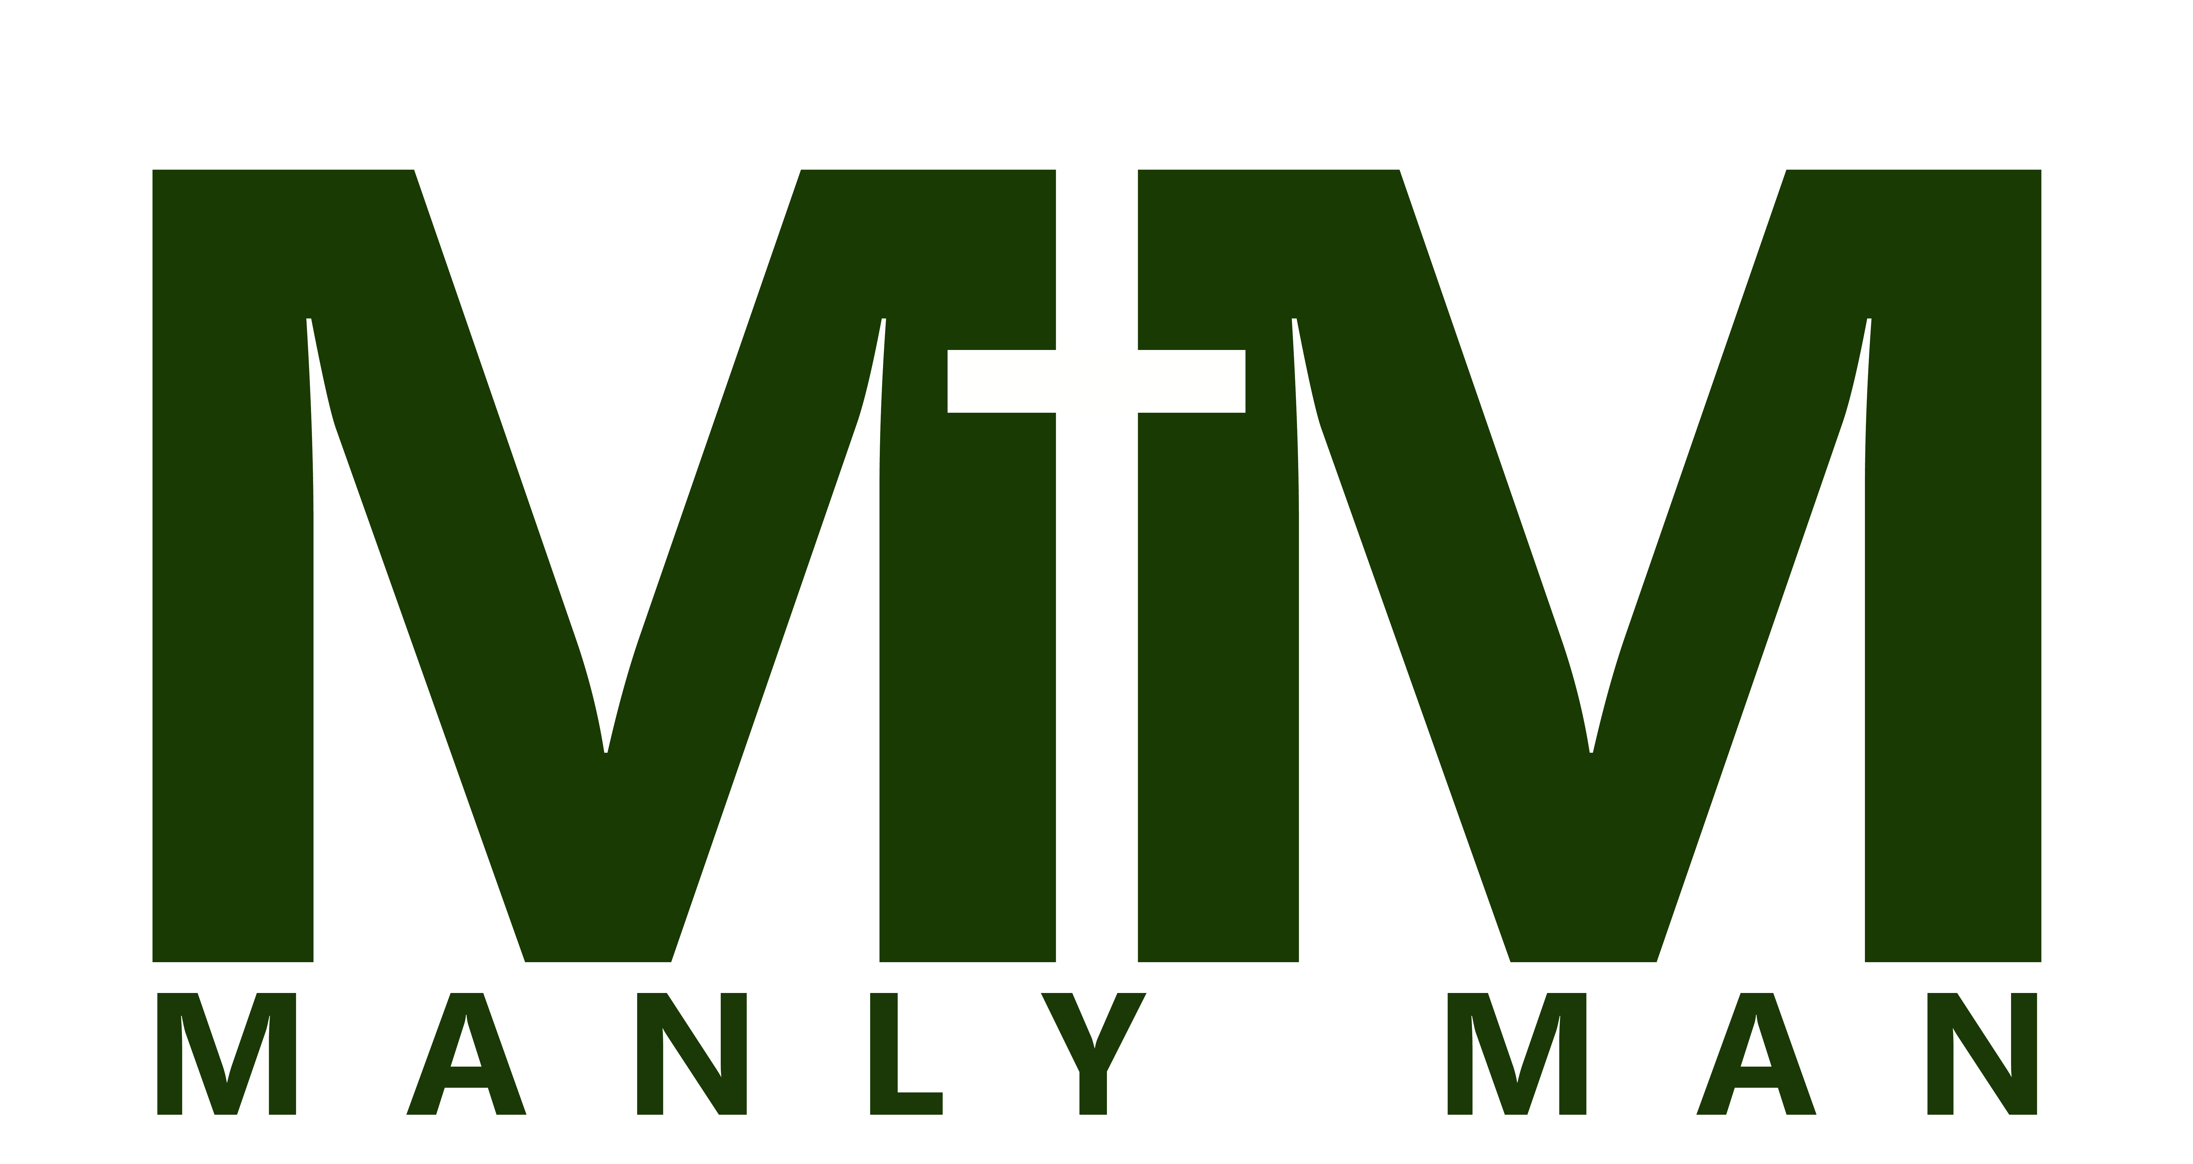
September 16th-17th
2017
First Name:________________ Last Name: ____________________
Circle One:
Grade: 6 7 8 9 10 11 12 Adult
Adult T-shirt Size: S M L XL XXL XXXL
**Cost includes: meals, stay at Camp Paquette, Activities, t-shirt, etc.
Cost: $35
Amount enclosed: _________

Manly Man// September 16th-17th//

Camp Paquette- Black Water State Forest

Saturday, September 16th

8:00 am – Meet at DUMC

9:00am- Depart DUMC

10:25am- Arrive at Camp Paquette

10:30am- Unpack at campsite/ Free time until Lunch
12:00am-LUNCH
12:30pm- Lesson #1 (Step Up)

1:00-5:00pm- Football, Ultimate, British Bulldog/Swim in Pond

5:15pm- Lesson #2 (Speak Out)

5:30pm- Prepare/Cook/Eat Dinner

7pm- Worship & Lesson #3 (Stand Strong)

7:30pm- Capture the Flag/Night Games
10pm- Bonfire/S’mores

Sunday, September 17th

7:00 am- Adult Wake up/Breakfast prep

7:30 am – Wake up
8:00am- Breakfast

8:30 am – Lesson #4 (Stay Humble)
9:00 am – Games

11:00am- Worship/Lesson #5 (Serve the King)

11:30am- Vote On Manly Man/Clean up and Pack

12:00pm- Lunch
12:30pm- Crowning of Manly Man of the Year

1:00pm- Leave for DUMC

2:30pm- Pick up at DUMC

Manly Man 2017 Packing List:
-A desire to draw near to Jesus
-Remember we have a strict NO PRANKING POLICY for all retreats…Even small things like silly string. Any student who attempts a prank or damages property will be sent home immediately*
-Bible, pen, & notepad.
-Swimsuit
-Personal Hygiene products (soap, shampoo, toothbrush, toothpaste, etc….) We don’t want to smell you!
-Towel, wash cloth, sleeping bag, twin sheets for the bed, blanket & pillow
-Water bottle
-Sunscreen, hat, & beach towel
-Several changes of clothes. No advertisements for negative products or the products themselves (alcohol, tobacco, drugs etc….)
-Please pack in one bag (limited space)
-Flashlight and glow in the dark gear (glow sticks)
-Bug spray
-Snacks if you like
Things to leave @ home:
-No paintball, air-soft, knifes or potato guns allowed AT CAMP

-Lap tops, video game systems, head phones or DVD players

-**No energy drinks**

-Or anything else that doesn’t promote community

-We reserve the right to check your bags for anything dangerous to yourselves or others (weapons, drugs, etc…)

Destin United Methodist Church

Medical Treatment Authorization and Permission Release

I (we) give ______________________________________(Name of Youth Member)

Permission to attend and participate in the youth activities at Destin United Methodist Church and it’s retreat. I (we) recognize that membership and participation in the youth program is voluntary, and while every reasonable precaution will be taken for the safety and well being of the participants, there are certain risks inherent in trips away from home and church youth activities.

In the event of an emergency illness or injury to the youth member, the adult volunteer leaders of DUMC will make every reasonable effort to contact me (us) for permission to obtain emergency medical and/or dental care. However, if the circumstances do not permit, I (we) authorize and consent to such emergency medical and/or dental care and treatment as may be necessary for the prompt treatment of the illness or injury. I (we) further agree to be financially responsible for the cost of emergency treatment and agree to reimburse DUMC and/or the adult leaders for any expense incurred as a result of such emergency treatment.

DUMC can use your student’s picture for advertisements, highlight videos, tagging and documentation.

_______________ _________________________________________________

Date Parent/Guardian Signature

_______________ ________________________________________________

Date Parent/Guardian Signature

During the times of most youth programs, I (we) can be reached at the following telephone numbers:

__________________________ ______________________________________

Area Code / Telephone Number Name or Location

__________________________ ______________________________________

Area Code / Telephone Number Name or Location

IMPORTANT: Emergency contacts other than a parent or guardian:

Area Code / Telephone Number:

Please Print Youth member’s Full Name:

Youth Member’s Date of Birth: _________________________

Allergies: __________________________________________

Current Medications: _________________________________

**Important: If child is currently on any type of medication, please send to this event to be administered by a designated adult. **

Name of Youth Member’s Regular Physician and Telephone Number:

Please list any special needs and/or medication schedule:

Health Insurance Carrier and Contract / Policy:

Is it okay to give your child Advil or Tylenol if needed during the weekend? _________________________

Christian Conduct Covenant
Destin United Methodist Church Youth Ministries
200 Beach Dr
Destin, FL 32541
- I hereby covenant to act in a Christian manner throughout youth activities and trips.

- I will follow the instructions and directions of the chaperones, leaders, interns, and staff.

- I will not use profanity at any time during youth activities, trips, and retreats, nor will I use language or jokes that are crude, offensive or sexual in nature.

- I will not bring or use alcohol, tobacco or drugs other than prescription medication prescribed to me or over-the-counter drugs approved by my parents. I will not bring, purchase or posses firearms, knives or weapons of any kind. I will also not bring, purchase or posses matches, lighters or anything that might be flammable or used to start fires.

- If using prescription medication or over-the-counter drugs, I will only use it in the manner approved of by my parents and doctor.

- I will respect the space and property of others.

- I will not be in the sleeping quarters or rooms of any member of the opposite sex, and I will not be alone in a room with a member of the opposite sex.

- I will not wear inappropriate clothing, skimpy clothing, clothing with logos of tobacco or alcohol products or clothing with sexual messages or innuendo.

- I will not bring video games, radio, ipod, ipad, MP3 player to youth trips.

- I will not use any language that is discriminatory, prejudicial or un-loving toward any individual or group of people.

- I understand that failure to follow these rules may result in my parents being called and sent home from a youth activity, retreat, or trip at the expense of your parents.

- I understand the responsibility I have as a Christian to hold others in the group accountable. So if I see (or am aware of) anyone breaking these rules, I will immediately tell an adult chaperone. I understand that failure to report any violation of these rules (that I have seen or am aware of) will be considered the same as having broken them myself.
As a family, we have read these rules, and we understand and consent to them.

______________________ ______________________
Parent child
______________________
child

